Cloud Computing Day 3

1)Create a S3 Bucket and create a folder in the bucket and upload a file in the folder.

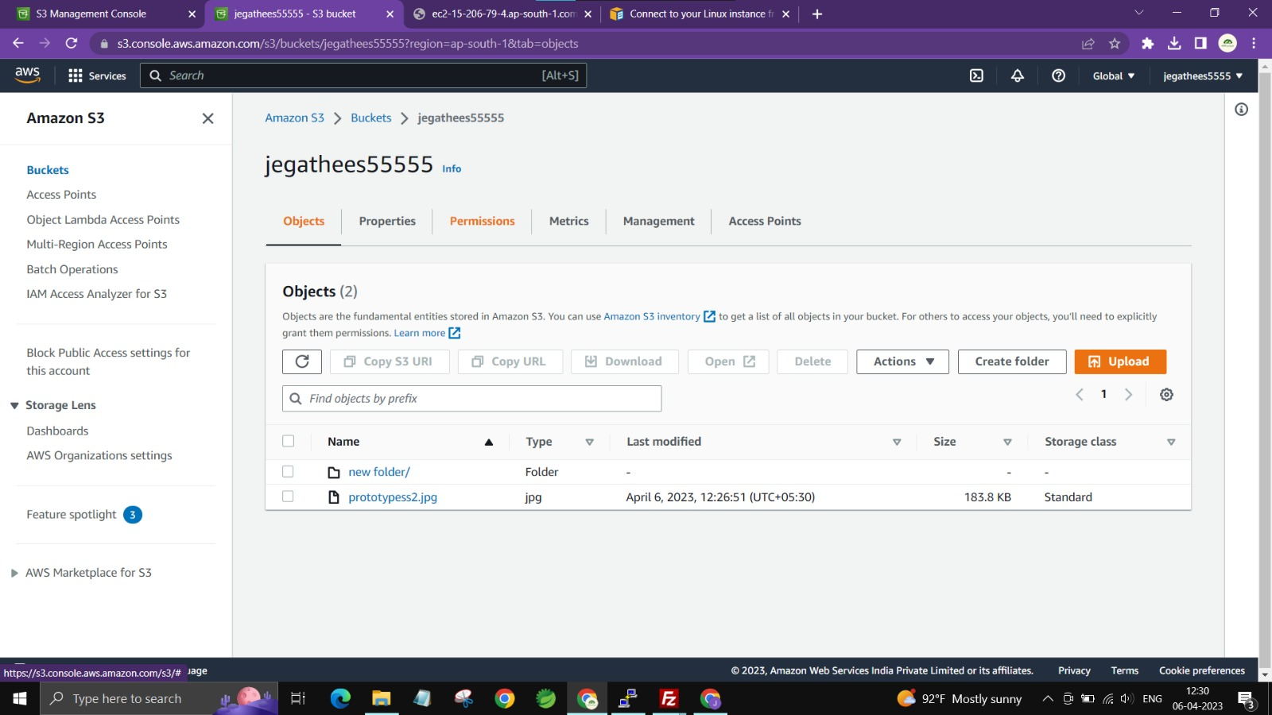

2)Disable "Block Public Access" for the bucket and enable public read access for a file.

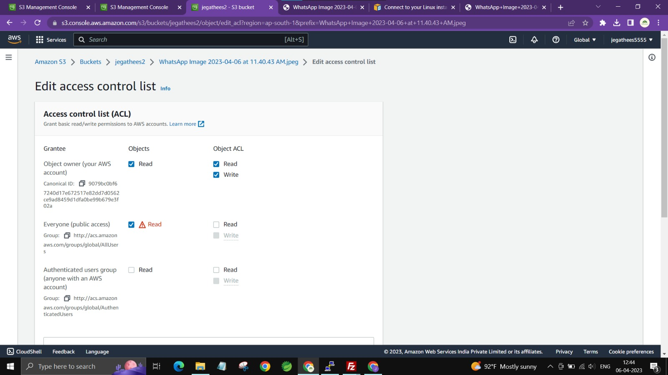

3)Create a bucket policy which should deny to read objects under a folder of a bucket.



4)Enable versioning objects for a bucket and upload objects with multiple versions of it.

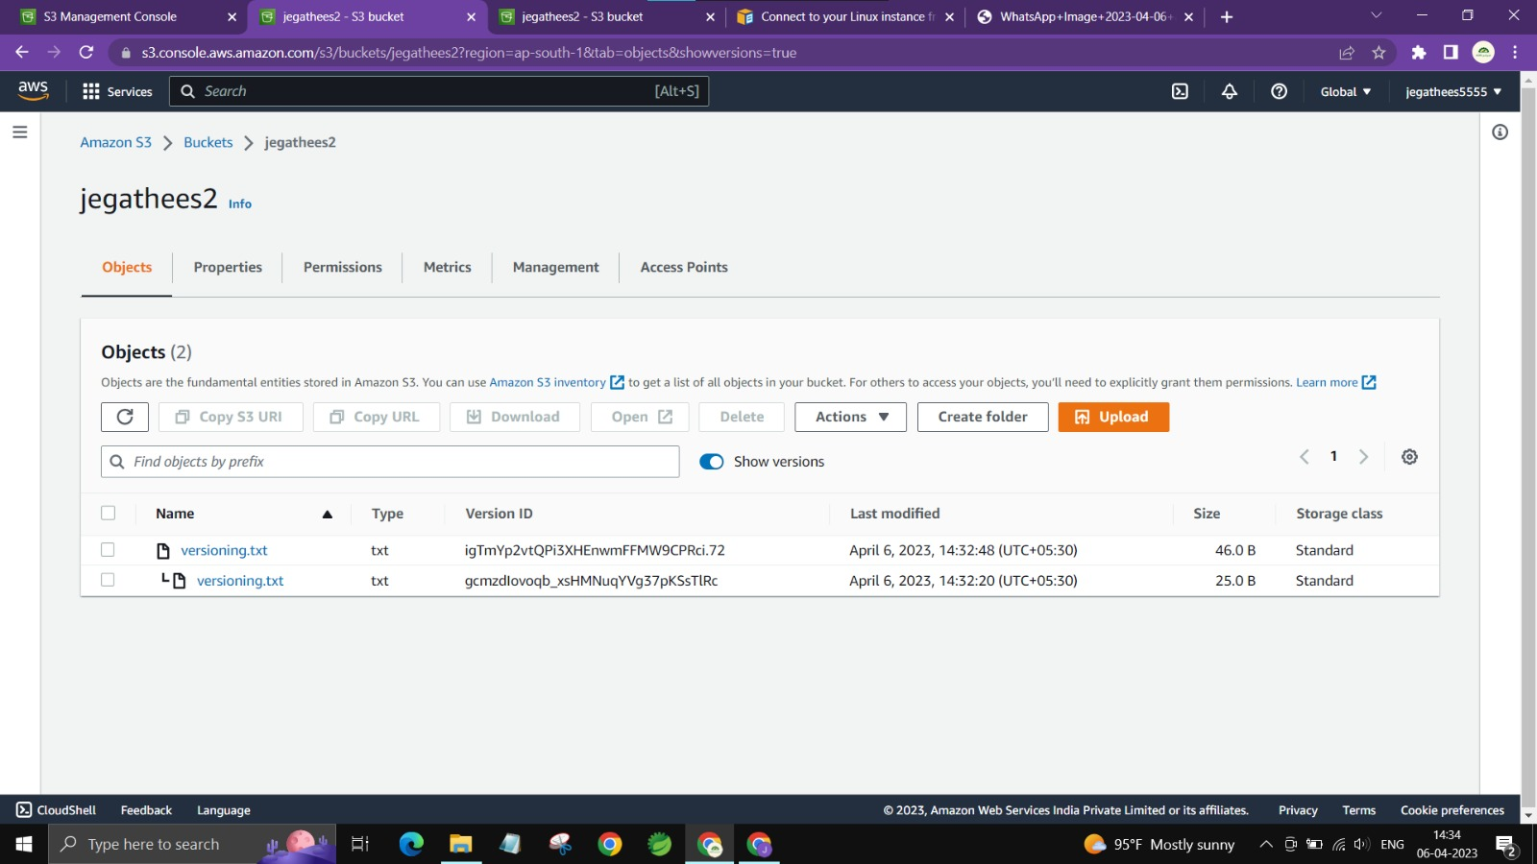

5)Host a static webpage in a bucket itself by using static website hosting feature of it.

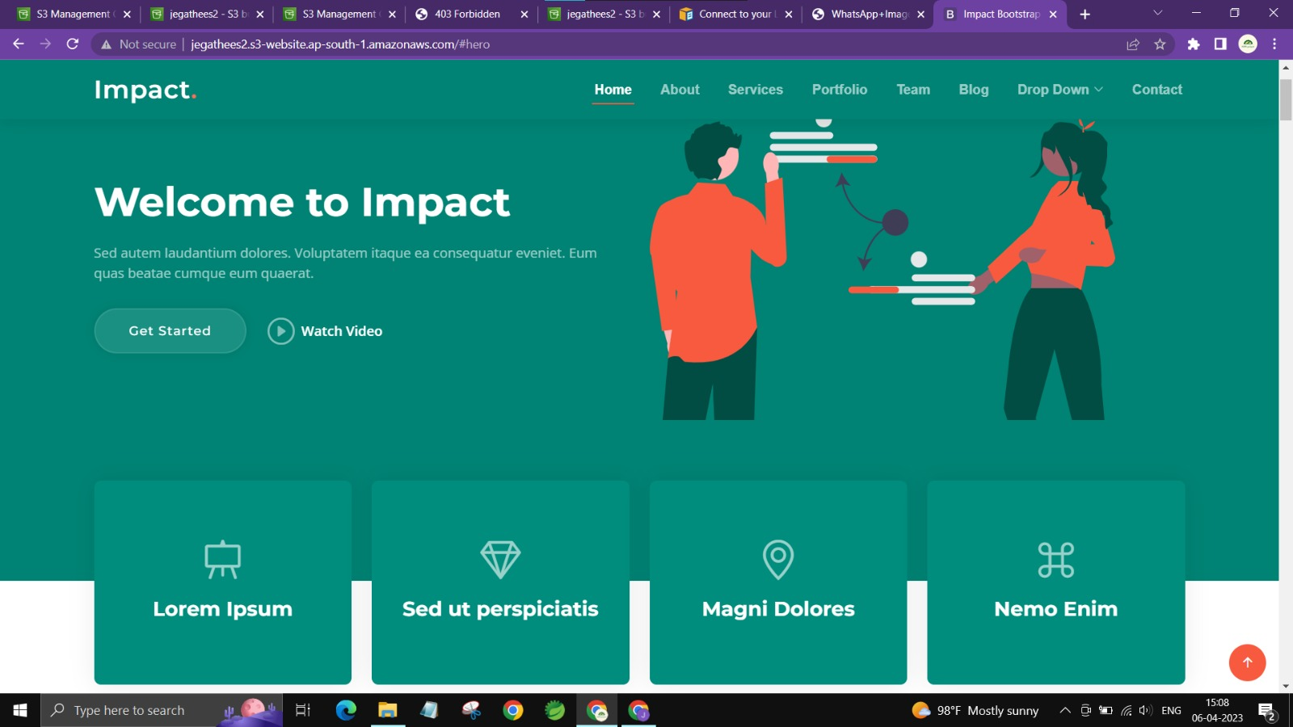

6)Enable a lifecycle management rule between various storage classes for a S3 bucket.

